Center for Academic Support
Hearnes 214
816.271.4524

Your TracCloud Account:
Every student at Missouri Western has a TracCloud student account in order to search and schedule appointments with CAS Tutors. Tutors also have a consultant profile in order to enter availability and manage appointments.
- Log in via Goldlink under the Student Academics card or the link on each Subject Tab on the CAS Webpage. Use the same username and password that you use for your email, Canvas, and Goldlink. TracCloud is part of the single sign-on system, so if you are logged into one of your Missouri Western accounts you will bypass the login page and go straight to your TracCloud dashboard.
- The first time you log in to your TracCloud account each semester you will be prompted to enter a cell phone number and opt in or out for text alerts (confirmations, cancellations, and reminders) for CAS tutoring appointments. If at any point you want to change your selection, you can click “Edit Bio…” at the bottom of your TracCloud dashboard to do so.
- Your TracCloud dashboard allows you to schedule tutoring appointments, submit papers for peer review, keep track of weekly study hall hours, and view your past visits in other Centers on campus that use TracCloud.

Overview:
Page 2 … Searching Availability and Scheduling an Online Writing Appointment
Page 4 … Submitting a Paper for Peer Review
Page 7 … Cancelling Appointments
Page 8 … No Available Timeslots
Page 9 … Starting your Online Writing Appointment
Page 10 … Downloading Zoom
Page 11 … TracCloud Restrictions
Searching Availability and Scheduling an Online Writing Appointment:
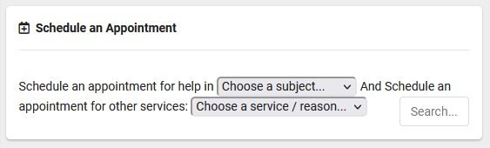
- Click on “Schedule an Appointment” to expand the search box.
- In the “Choose a subject…” drop down menu, select the course you would like a tutor for. TracCloud will automatically populate your current enrollments.
- In the “Choose a service/reason…” drop down menu, select the kind of tutoring you want to receive:
  - For an online Zoom appointment with a Writing Tutor, select Writing
- Click “Search” and the next available appointments will appear in a pop-up window.
  - If you do not see any appointments, click the “Load more…” button.
- Pick which appointment works best for you and click on it. A new screen will pop up and prompt you to enter some information to reserve the appointment.
  - If given the option, choose whether the session is in-person or online.
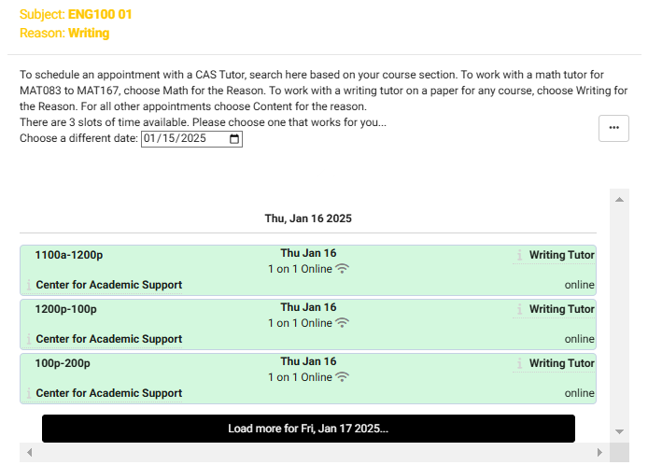
  - Enter a valid phone number.
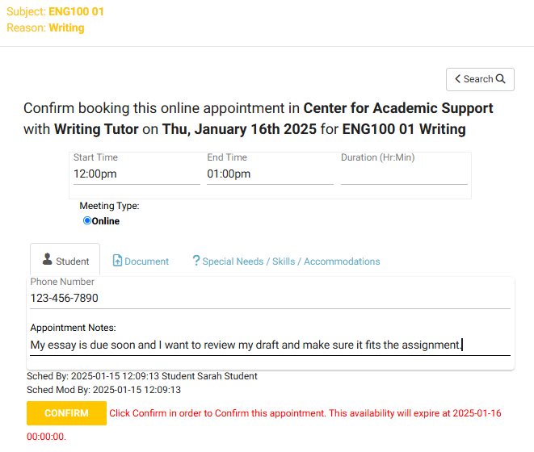
  - Type a note to let the tutor know what type of assignment or document you want to discuss during your appointment.
- Click “Confirm”
- You and the tutor will get a confirmation email with the details of your appointment.
- After confirming the appointment, you can switch to the Document tab and click the “+New” button to upload files.
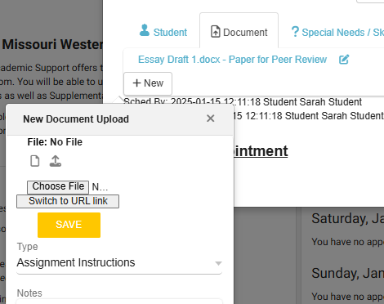
  - For type, choose “Assignment Instructions” and upload the directions or rubric then click save.
  - Then add another file and for type, choose “Paper for Peer Review” and upload your paper.

Submitting a Paper for Peer Review:
- Click on “Schedule an Appointment” to expand the search box.
- In the “Choose a subject…” drop down menu, select the course you are writing a paper for or select professional writing if the paper is not for a course.
- In the “Choose a service/reason…” drop down menu, select Submit a Paper (Peer Review).
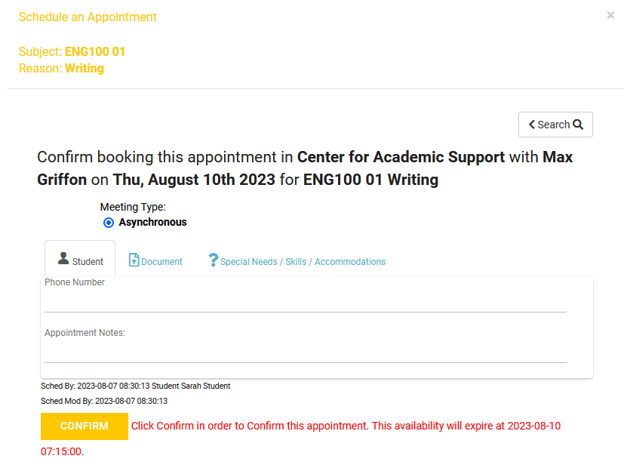
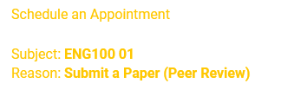
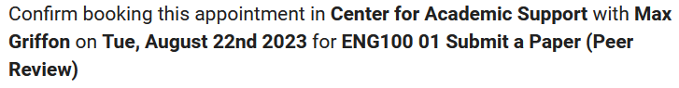
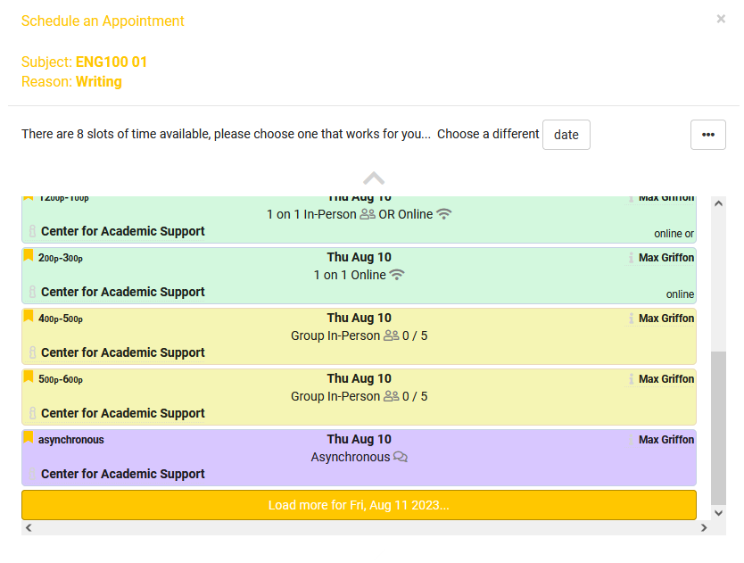
- Click “Search” and look for the purple availability block titled “Asynchronous”
- Clicking this block will open a new screen prompting you to enter a valid phone number and notes for the tutor, then click confirm.
- After confirming the appointment, you can switch to the Document tab and click the “+New” button to upload files.
  - For type, choose “Assignment Instructions” and upload the directions or rubric then click save.
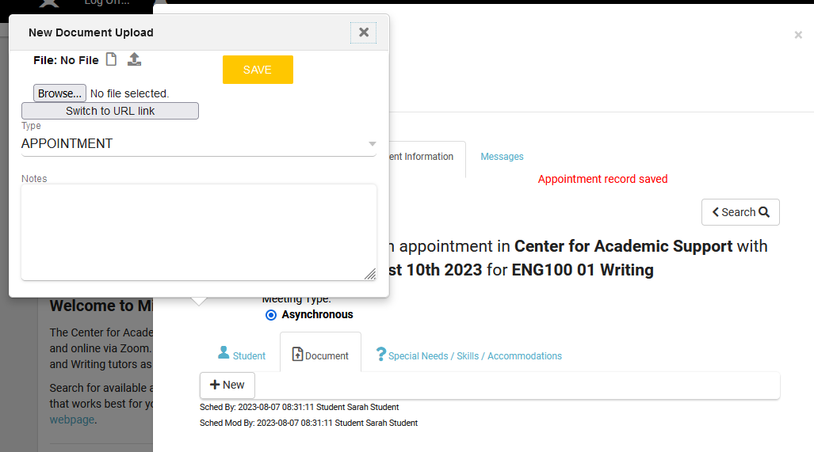
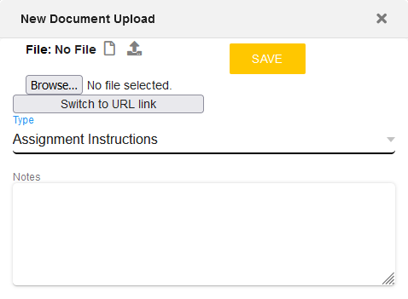
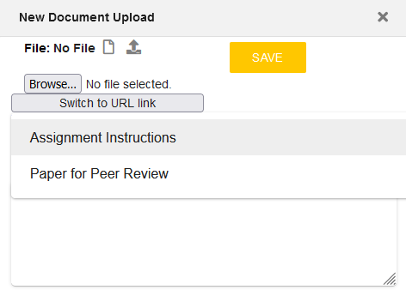
  - Then add another file and for type, choose “Paper for Peer Review” and upload your paper.
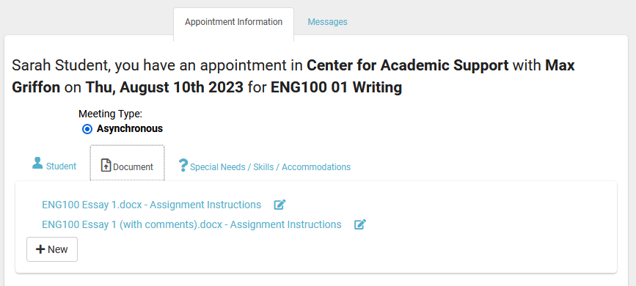
- The tutor will be sent an email notifying them that you submitted a paper. On your dashboard you will see the peer review session listed under Asynchronous Communications In Progress.
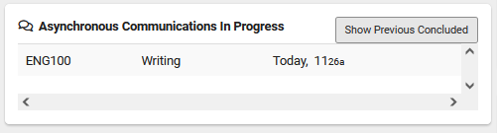
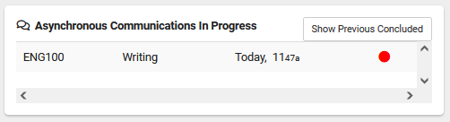
- When the tutor adds a comment to the session you will see a red dot appear next to the listing on your dashboard
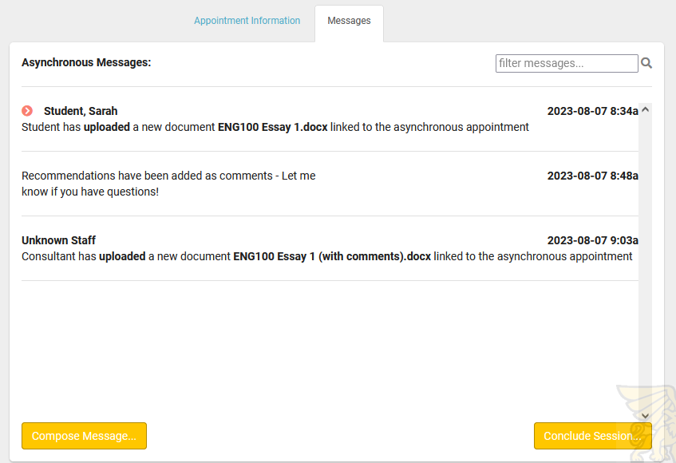
- You can click on the peer review session listing and go to the messages tab to see the Tutor’s response.
- From here, you have you three options:
  - Click “Compose Message…” if you have questions or would like to discuss the recommendations from the tutor.
  - Click “Conclude Session…” if you are satisfied with the recommendations and need no further assistance.
  - Make changes to your paper and upload the new version for the tutor to review.
    - To upload a new document, switch to the Appointment Information tab, click Document, then click “+New”
- Once you or the Tutor concludes the session, it will no longer show under Asynchronous Communications “In Progress”
- To view past peer review sessions, you can click the “Show Previous Concluded” button.

Cancelling Appointments:
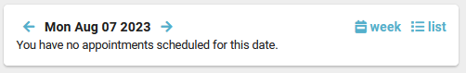
- You can see all upcoming appointments on your TracCloud dashboard. Click “week” to expand the calendar to show appointments later in the week.
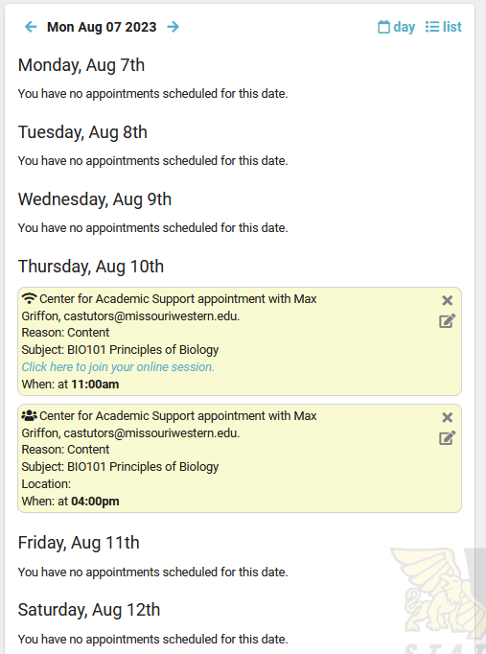
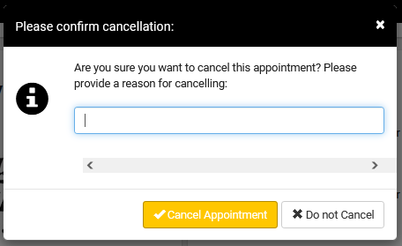
- To cancel an appointment, click the “x” on the top right of the appointment box. A new screen will pop up to confirm the cancellation. Enter a note here to let the tutor know why you need the cancel.
- If you need to cancel an appointment that is scheduled to begin in less than 24 hours, you must email the tutor directly. Their email address is listed on the appointment box as well as in the original confirmation email for the appointment.

No Available Time Slots:
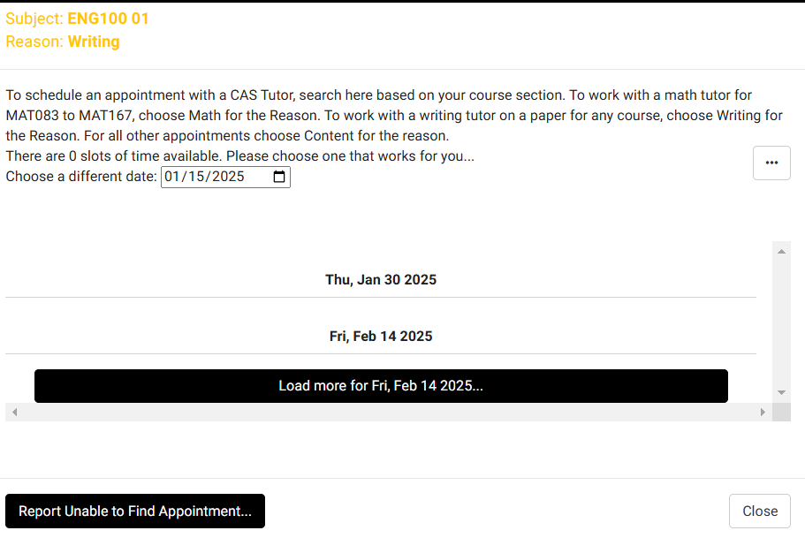
If you are searching for an appointment and see there are 0 slots of time available, you can click the black button at the bottom of the screen labeled “Report Unable to Find Appointment…”

This will open a new screen where you can complete a report and have it sent to CAS Staff. From this screen you can also click the link to complete a Content tutor request form.
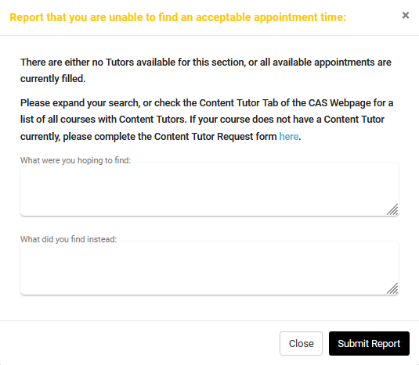
Starting your Online Writing Appointment:





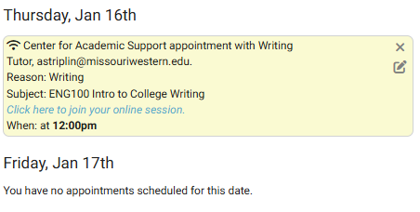
- On your TracCloud dashboard, you will see your upcoming appointments.
Icon Glossary:
Online 1 on 1

Online group

In-person 1 on 1

In-person group

- The “Click here to join your online session” link will open the tutors Zoom room. This link will only let you join the session 15 minutes before your scheduled meeting, but it will remain active for the duration of your scheduled appointment.
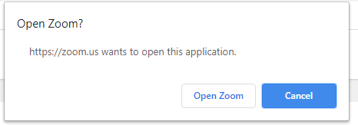
- After clicking the link, a new window will pop up and prompt you to either: download the Zoom application if you haven’t already or launch the meeting using Zoom.
- You may be placed in a waiting room until the tutor opens the meeting room. Once the tutor opens the meeting room, a new box will pop up for you to enter your name and click “Join”
- During the meeting you will have a control panel at the bottom of your screen. This panel gives you the options to mute/unmute your microphone, turn your video on and off, share your screen, and open the chat box.

Downloading Zoom:
In order to use Zoom, you will need internet access and a device that has a working camera, microphone, and speakers
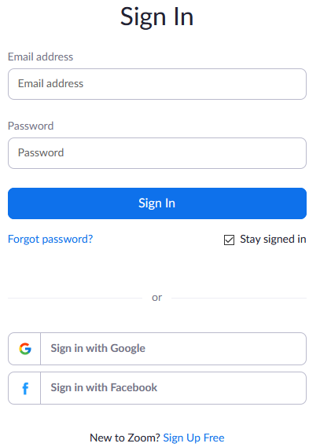
- Students must open a Zoom account first.
  - To download from the website: https://zoom.us/
Click Sign Up, then Sign in with Google using your Missouri Western account.
If you are already signed into another Google account on your device your Zoom account will be linked to that email, so make sure you are only logged into your Missouri Western Google account.
If you have not used Zoom before, you will need to download the application in order to join meetings. To download from the website, click on “Host a Meeting” and choose Video On. This will open a pop up and ask you to download the application and launch Zoom.
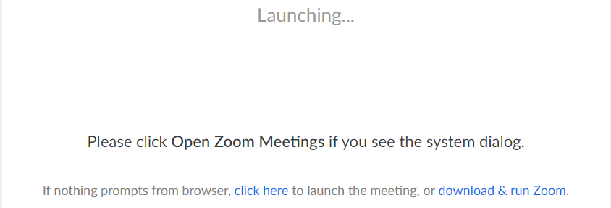
  - To Download from your meeting:
When you click to enter your appointment, a pop up will appear if you do not have the application downloaded. Download Zoom and sign in with Google using your Missouri Western account. From here you will be able to launch the application and join the Zoom meeting for your scheduled appointment.

Note: If you are unable to use Zoom, please contact the CAS, 816.271.4524, to schedule an appointment via phone or other communication platform.
TracCloud Restrictions:
- Appointments must be scheduled at least 24 hours in advance and at most 14 days in advance.
- Appointments cannot be cancelled online if they are scheduled to begin in less than 12 hours. Students must contact the tutor via email instead.

